**WEEK-10**

**NAME-SANCHIT JAIN**

**BATCH-B-7**

**ENROLL-21103192**

1.

x = 1 count = 0

x = 1 count = 1

x = 1.1 count = 0

**2.**

**1**

**2**

**3.**

#include<iostream>

using namespace std;

template <class T>

class calculator

{

private:

T n1,n2;

public:

calculator(T a1, T a2)

{

n1=a1;

n2=a2;

}

T add()

{

return n1+n2;

}

T sub()

{

if(n2<n1) return n1-n2;

else return n2-n1;

}

T mult()

{

return n1*n2;

}

T divi()

{

if(n1>n2) return n1/n2;

else return n2/n1;

}

};

int main()

{

calculator<int> a(2,3);

cout<<"Sum is "<<a.add()<<endl<<"Difference is "<<a.sub()<<endl<<"Product is"<<a.mult()<<endl<<"Quotient is "<<a.divi()<<endl;

calculator<float> b(2.5,3.2);

cout<<"Sum is "<<b.add()<<endl<<"Difference is "<<b.sub()<<endl<<"Product is"<<b.mult()<<endl<<"Quotient is "<<b.divi()<<endl;

return 0;

}

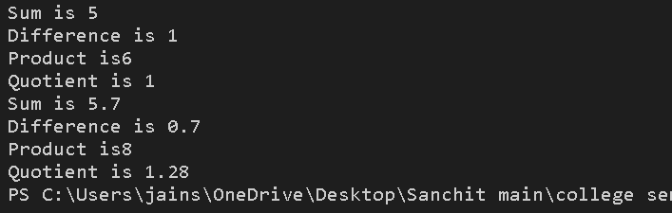

**4.** #include<iostream>

using namespace std;

template <class T>

T minimum(T n1, T n2)

{

if(n1<n2) return n1;

else return n2;

}

template <class T>

T maximum(T n1, T n2)

{

if(n1>n2) return n1;

else return n2;

}

int main()

{

int m, n;

cout<<"Enter two integers";

cin>>m>>n;

cout<<"Minimum is: "<<minimum(m,n)<<endl<<"Maximum is:"<<maximum(m,n)<<endl;

float a, b;

cout<<"Enter two floating point numbers";

cin>>a>>b;

cout<<"Minimum is: "<<minimum(a,b)<<endl<<"Maximum is: "<<maximum(a,b)<<endl;

return 0;

}

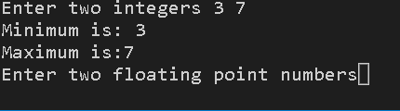

**5.**

#include <iostream>

using namespace std;

template<class T>

class MyVector

{

int n;

T *arr=new T[n];

public:

MyVector(int m)

{

n=m;

cout<<"Enter Vector Elements"<<endl;

for(int i=0;i<n;i++)

{

cout<<"Enter element "<<i+1<<": ";

cin>>arr[i];

}

}

int size()

{

return n;

}

void push_back(T s)

{

n++;

T *arr=new T[n];

arr[n]=s;

}

void pop_back(T s)

{

n--;

T *arr=new T[n];

arr[n]=s;

}

~MyVector()

{

cout<<"Vector Elements"<<endl;

for(int i=0;i<n;i++)

{

cout<<"Element "<<i+1<<": "<<arr[i]<<endl;

}

}

};

int main()

{

cout<<"Enter number of elements in the vector"<<endl;

int v;

cin>>v;

MyVector <int> v1(v);

cout<<"Initial Vector Size: "<<v1.size()<<endl;

cout<<"Enter element for pushing";

int m,n;

cin>>m;

v1.push_back(m);

cout<<"Vector Size after pushing: "<<v1.size()<<endl;

v1.pop_back(m);

cout<<"Vector Size after popping: "<<v1.size()<<endl;

return 0;

}

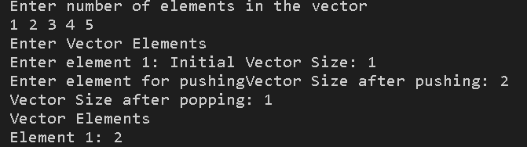

**6.** #include <iostream>

#include <vector>

#include<algorithm>

using namespace std;

int main()

{

vector <int> v1,v2;

cout<<"For the First Array"<<endl;

int n;

cout<<"Enter Element: ";

cin>>n;

while(n>=0)

{

if(n>=0)v1.push_back(n);

cout<<"Enter Element: ";

cin>>n;

}

cout<<"For the Second Array"<<endl;

cout<<"Enter Element: ";

cin>>n;

while(n>=0)

{

if(n>=0)v2.push_back(n);

cout<<"Enter Element: ";

cin>>n;

}

cout<<endl<<endl;

for(auto i=v2.begin();i!=v2.end();i++)

{

int c=0;

for(auto j=v1.begin();j!=v1.end();j++)

{

if(*i == *j) c++;

}

if(c==0) v1.push_back(*i);

}

for(auto i=v1.begin();i!=v1.end();i++)

{

if(*i>*(i+1))

{

int t=*i;

*i=*(i+1);

*(i+1)=t;

}

}

sort(v1.begin(),v1.end());

cout<<"The Updated Vector is: {";

for(auto i=v1.begin();i<v1.end();i++)

{

cout<<*i<<",";

}

cout<<*(v1.end())<<"}";

}

